

Practices for Secure Software Report

Table of Contents
Document Revision History 3
Client 3
Instructions 3
Developer 4
1. Algorithm Cipher 4
2. Certificate Generation 4
3. Deploy Cipher 4
4. Secure Communications 4
5. Secondary Testing 4
6. Functional Testing 4
7. Summary 4
8. Industry Standard Best Practices 4

Document Revision History

Version | Date | Author | Comments
1.0 | 15 October 2026 | Jacob Williams

Client



Instructions

Submit this completed practices for secure software report. Replace the bracketed text with the relevant information. You must document your process for writing secure communications and refactoring code that complies with software security testing protocols.

- Respond to the steps outlined below and include your findings.
- Respond using your own words. You may also choose to include images or supporting materials. If you include them, make certain to insert them in all the relevant locations in the document.
- Refer to the Project Two Guidelines and Rubric for more detailed instructions about each section of the template.

Developer
Jacob Williams

Algorithm Cipher

For Artemis Financial, I recommend the SHA-256 algorithm. It allows Artemis Financial to create an individual hash value that gets compared to the previous hash value to ensure the data has not been tampered with. This hash value is a very large unique number, making it very robust and difficult to reproduce, and it defends against attacks since it offers Artemis Financial the capability to detect minor tampering. A cipher’s hash function maps the data that is input into a fixed-length footprint that is a one-way function. SHA-256’s bit length is the number of buckets the values the data can go into, and with a 128-bit collision resistance, it makes it extremely unlikely for the same hash value to be produced (Computer Science Division, 2017).

Unlike SHA-256, which does not use an encryption key, symmetric encryption uses the same secret key to encrypt and decrypt the data it is given, while asymmetric encryption uses a public and private key pair. Cryptography uses random numbers to generate these unique keys to prevent attackers from cracking the algorithm and getting the protected data. Over the course of history, we have had encryption used by Julius Caesar and the Roman Army (Schneider, 2024), WWII with Alan Turing's Bombe device, then the 1970s standardization of the Data Encryption Standard (DES) and RSA, which generated a key so that you could exchange information secretly by comparing the two keys.

In modern times, we use AES-256 encryption, SHA-256 hashing, and are now progressing into the world of Post-Quantum Cryptography (PQC), which is designed to protect from future attacks by quantum computers. Overall, SHA-256 allows Artemis Financial to practically keep a digital ledger in the sense of sensitive data being transferred digitally. SHA-256 allows you to ensure the customer's sensitive banking information has not been tampered with, and can be complemented by AES-256 for encryption as well. This recommendation is the best option for Artemis Financial to protect this data through speed, flexibility, and data integrity, all of which customers need in a rapidly evolving technological world faced with many digital threats.

Certificate Generation
Insert a screenshot below of the CER file.

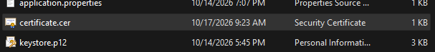

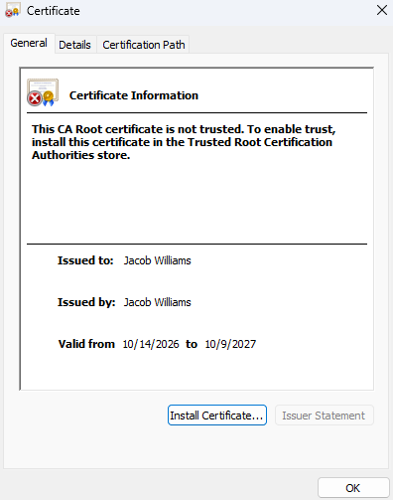

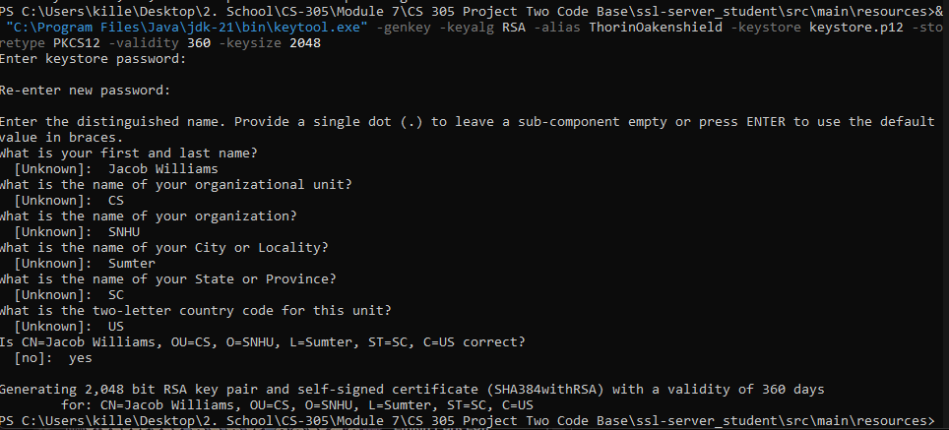
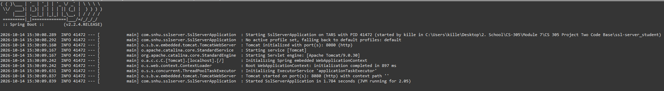

Deploy Cipher
Insert a screenshot below of the checksum verification.

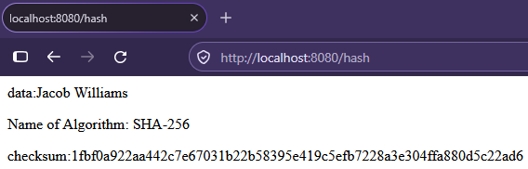

Secure Communications
Insert a screenshot below of the web browser that shows a secure webpage.

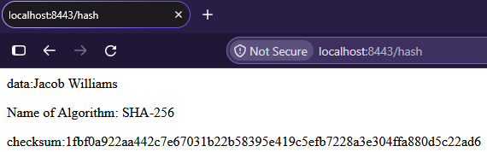
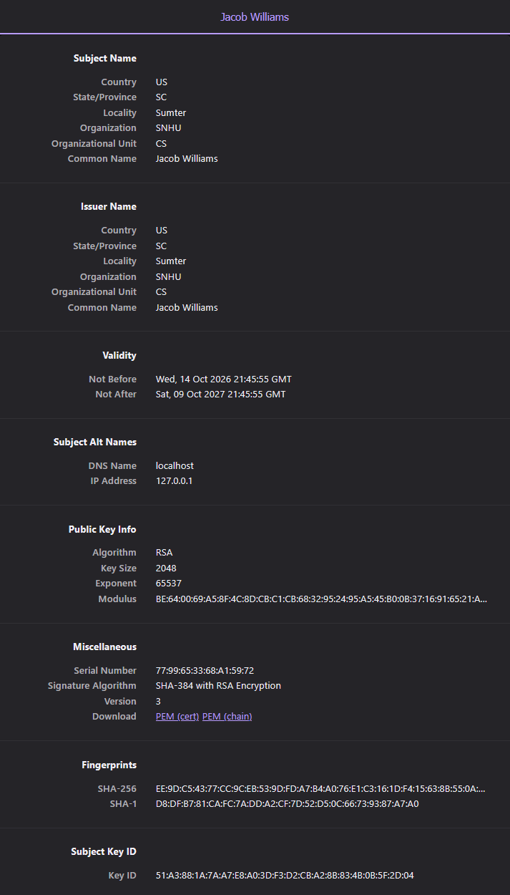

Secondary Testing
Insert screenshots below of the refactored code executed without errors and the dependency-check report.

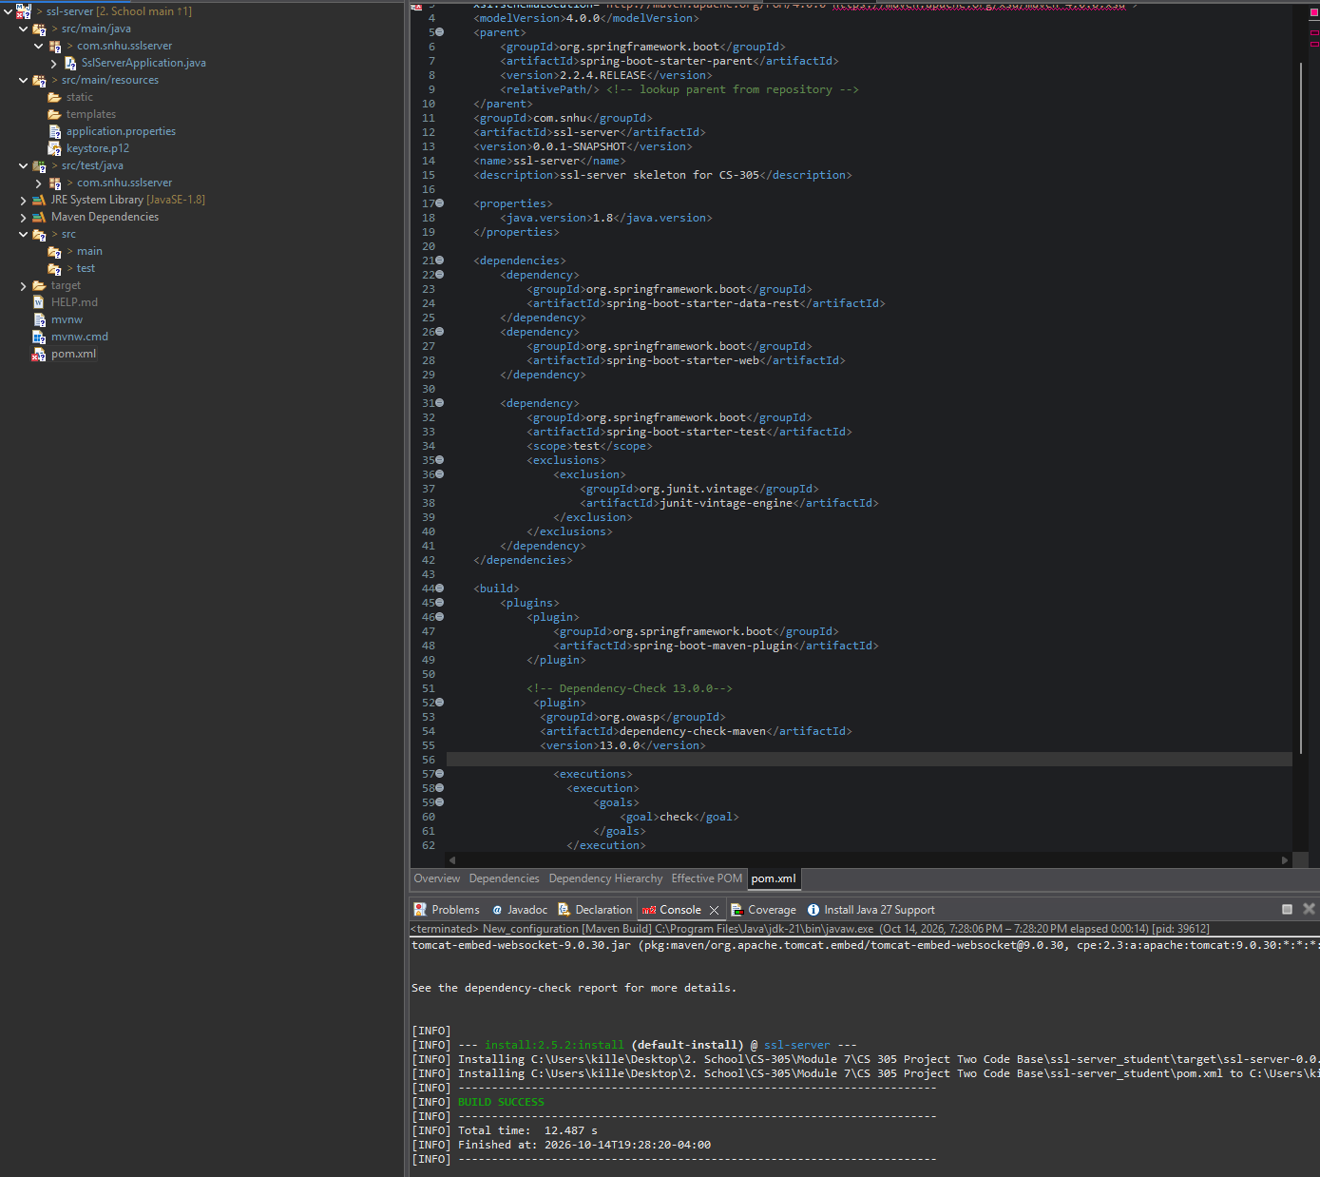

Edited Codebase Dependency-Check (I refactored, then ran this scan first):
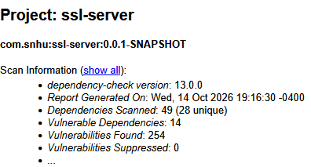
Unedited Codebase Dependency-Check (Ran scan again with a fresh copy of the codebase):
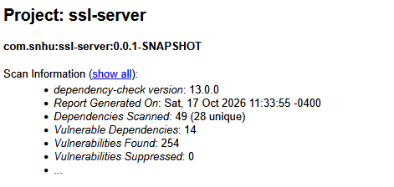

Functional Testing
Insert a screenshot below of the refactored code executed without errors.

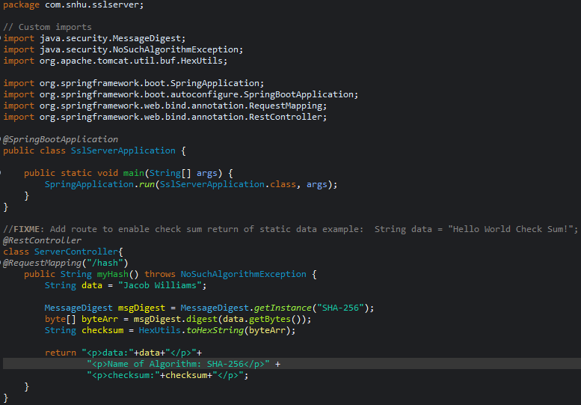
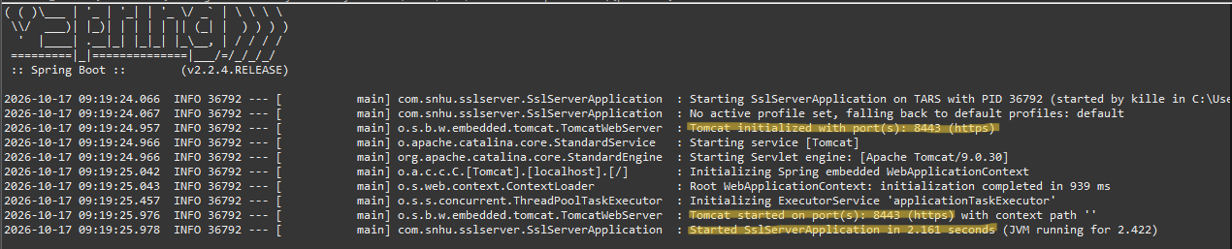

Summary

Using the vulnerability assessment flowchart, I primarily focused on cryptography, client/server communications, and code quality. For cryptography, I implemented the use of the SHA-256 algorithm to generate a checksum, which can be used to see if the data has been altered. I then used a self-signed certificate using Java’s Keytool program. I then added HTTPS using the Spring Boot application instead of standard HTTP. HTTPS adds an extra layer by encrypting the data being sent, which is crucial for a banking application.
I modified the application's properties file to use the keystore certificate I generated, which allowed me to successfully communicate with it over HTTPS, and I also focused on code quality by following standard naming conventions and proper syntax. After refactoring the application, I ran Maven and the OWASP Dependency-Check tool to scan it for known security vulnerabilities. This scan showed potential security concerns that would require more in-depth investigation. Overall, the changes made helped protect the integrity of customer data, secure and encrypt communications over HTTPS, and provide a security test to manage and mitigate potential security risks of the Artemis Financial application.

Industry Standard Best Practices

To maintain Artemis Financial’s existing security, I chose to use already proven tools and algorithms to implement in the application. For example, I used the SHA-256 hashing algorithm that is widely supported and trusted which is complemented by AES-256 encryption, and then used the OWASP Dependency Check tool, which uses a large database of known security vulnerabilities to find any known vulnerabilities as well. I also used Java’s own Keytool application to generate a self-signed certificate to communicate through HTTPS, which is also widely trusted and used for most web applications due to its secure communication benefits.

These best practices are extremely important for Artemis Financial as they deal with sensitive banking information and customers’ finances, which could be everything to them. By using these established security measures, scans and implementations can identify weaknesses and further protect the customer and their data. It also helps protect Artemis Financial from legal issues, exploitation, or loss of trust as a company from its customers. While the dependency check scan identified security vulnerabilities, it must be investigated further to determine false positives and ensure they are applicable to the application. The peace of mind these best practices bring to the table is invaluable for Artemis Financial.

References
Computer Security Division, I. T. L. (2017, January 4). Hash Functions | CSRC | CSRC. CSRC | NIST. https://csrc.nist.gov/projects/hash-functions
Schneider, J. (2024, July 17). The History of Cryptography | IBM. https://www.ibm.com/think/topics/cryptography-history

